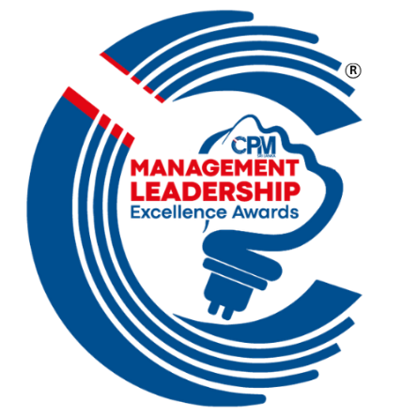
Part A
Details of the Applicant

01 | Full Name of the Applicant
02 | Company Name and the Address
03 | Designation
04 | Applicant Category  (Pls. tick appropriately) | C-Suite Leadership
04 | Applicant Category  (Pls. tick appropriately) | Executive Decision Maker Leadership
04 | Applicant Category  (Pls. tick appropriately) | Emerging Managerial Leadership
05 | Name of the Sector/ Cluster Award | Eg. Banking (Public Sector)
05 | Number of the Sector/ Cluster Award | Eg. 1.1
06 | Total Number of Pages in the Report
07 | Compliance of Deadline & Rules, Template, and other Instructions (10%) | (for office use only)
08 | Declaration  I affirm the accuracy and completeness of the information presented in this document pertaining to the Management Leadership Excellence Awards 2026, an event hosted by the Institute of Chartered Professional Managers of Sri Lanka (CPM Sri Lanka).  I declare that the details provided are true to the best of my knowledge and belief. I understand that any deliberate misrepresentation within this document may render it null and void. I further acknowledge and accept that the decision of the panel of judges, as approved by the Governing Council of CPM Sri Lanka, is final and binding.
 | ……………………………………..  Signature of the Applicant & Date | ……………………………………………..  Name & Designation of the Endorser | …………………………………………....  Rubber Stamp of the Endorser

Part B
TEMPLATE OF THE REPORT

01. | Brief profile of the applicant
Total 05 marks | 1-2 Marks  Average |  | 3-4 Marks  Good |  | 5 Marks  Very Good
(Make it very brief)

02. | Key challenges/situations emerged/faced
Total 20 marks | 1-10 Marks  Average |  | 11-15 Marks  Good |  | 16-20 Marks  Very Good
(Please describe the key challenges or situations you faced. Provide a brief comparison with the previous period to illustrate the context).

03. | Managerial Leadership approach
Total 10 marks | 1-5 Marks  Average |  | 6-8 Marks  Good |  | 9-10 Marks  Very Good
(Please select only one of the following to highlight your managerial leadership approach)
01. | Demonstrating Visionary Leadership
02. | Driving Innovation and Creativity
03. | Showcasing Community Service Orientation and/or Corporate Social Responsibility
04. | Engaging in Brand Building and Achieving Marketing/Business Excellence Marketing/BusinesExcellence
05. | Enabling Diversification and Growth Strategy
06. | Exhibiting Exemplary Management Skills
07. | Inspiring Strategic Leadership and Trend Capitalization
(Please explain/justify in brief as per the relevant characteristics).

04. | Impact of managerial Leadership on Organisational Performance (Provide a minimum of three pieces of evidence) – Initiatives/Output/Outcome/Results/Highlight
(Clearly present three pieces of evidence that indicate how your leadership has contributed to
get the business sustaining and growing.)
Total 60 marks
Evidence 01-  20 marks | 1-10 Marks  Average |  | 11-15 Marks  Good |  | 16-20 Marks  Very Good
Evidence 02-  20 marks | 1-10 Marks  Average |  | 11-15 Marks  Good |  | 16-20 Marks  Very Good
Evidence 03-  20 marks | 1-10 Marks  Average |  | 11-15 Marks  Good |  | 16-20 Marks  Very Good
05. | Additional Supporting Aspects
Provide briefly overall organisational performance indicators such as growth rate, market volume, share, profitability etc.
Include any other noteworthy elements that support the nomination, awards/public recognition/letters of recognition/event links/report/newspaper article/company annual report
Total 5 marks | 1-2 Marks  Average |  | 3-4 Marks  Good |  | 5 Marks  Very Good
(This should be very brief, and you may provide some annexures if required.)

Part C
general guidelines

- Applicants must follow the report template given by CPM Sri Lanka for the report writing.

- Applicants are expected to make a 10-minute video of the multi-media presentation based on the factors structured and articulated in the report. You are allowed to use appropriate AI tools for the video.

- Applicants should submit a report containing 500–1,000 words through the designated online submission form available on the CPM Awards Official Website. The submission link will be provided when the submission period officially opens. The report must be uploaded in PDF format.

- Font used for all texts should be in Arial/Calibri/Times New Roman 12-point font. The main headings and the sub-headings should be bold. All texts should be justified.

- The report of the applicant must be endorsed by the organisation’s Chairman/CEO/MD/Proprietor as true and correct (company rubber stamp/seal and signature). Applications submitted by entrepreneurs or sole proprietors must be accompanied by an affidavit attested by a Justice of the Peace (JP) or a qualified lawyer.

- The Report, which does not adhere to the given template will be rejected. Application fee is non-refundable.

- As the evaluation process is conducted in English, all report content and video presentations must be prepared and submitted in English.

- Applicants who earn 61% or above marks, but not secure any such title will be recognized as the ‘Merit in CPM Management Leadership Excellence Awards 2026’

- Applicants who earn 50% to 60% marks, but do not secure any such title will be recognized as the ‘Certificate of Recognition in CPM Management Leadership Excellence Awards 2026’

- Applicants who earn 49% or below marks will not be recognized.

